Unit I – INTRODUCTION to CRITICAL THINKING & REVIEW of UNITED STATES HISTORY to 1865

Summary—This unit is an introduction to what history is all about: critical thinking. Basically, critical thinking means thinking for yourself. It means evaluating the information that you receive & coming to your own conclusions about it. However, good critical thinking does not just entail stubborn independence. Good critical thinking comes from a complex set of skills. A major goal of this course is to develop these skills. At the same time, we will be reviewing some of the information from your previous year in U.S. History.

Essential Question
Essential questions are the big picture questions of the unit. Often times they are the type of question that will be asked during the open response section of the unit test. They can usually be answered in a number of ways based upon your interpretation of history. This unit’s essential question is unique: it is a question that we will refer to throughout the entire year.
- How did America emerge as a global superpower in the 20th century?
Critical Thinking Diagram

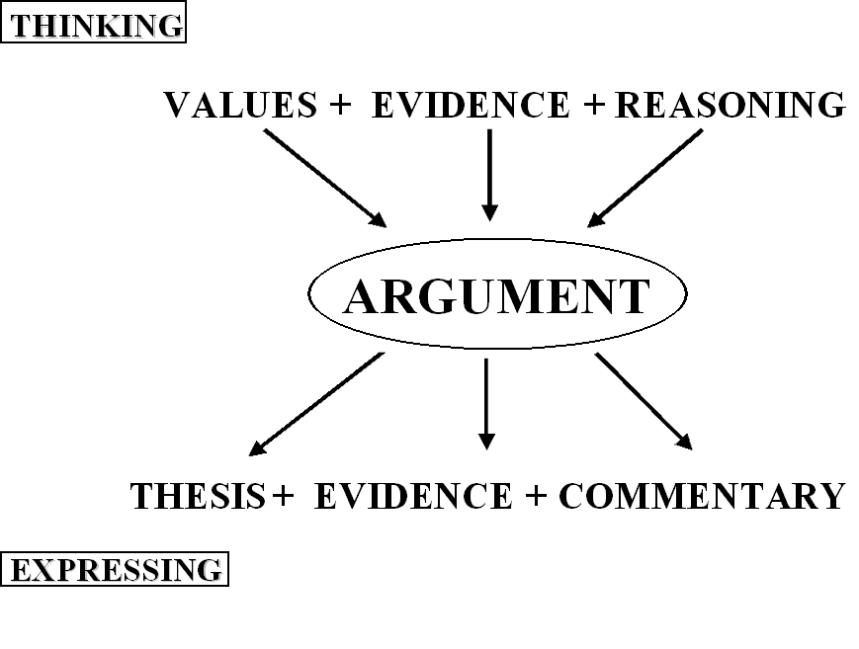

Sources
- Powerpoint: The Critical Thinking Diagram
- Chart: Values Definitions
- Recognizing Types of Reasoning

Content Questions
Throughout this Unit, and all others, there will be several content questions. These questions must be answered using the key terms, underlining and numbering each key term. Be sure to also cite your source of information from the sources above. Content questions are always due the day of the unit test.
- What is ‘history’ & why is ‘argument’ at the center of the study of history?
- What are ‘values’? What values do we focus on in this course?
- What is ‘evidence’? What is the difference between evaluating evidence & organizing evidence?
- What is ‘reasoning’? What are the different categories of historical reasoning? What are the different elements of each category of historical reasoning?
- What is a ‘thesis’? What are the characteristics of a good thesis?
- What is ‘commentary’?

Key Terms

- History
- Argument
- Values
- Individualism
- Collectivism
- Liberty
- Order
- Equality
- Hierarchy
- Democracy
- Authority
- Capitalism
- Centralization
- Evidence
- Reasoning
- Cause & Effect
- Cause
- Effect
- Descriptor
- Generalization
- Whole
- Part
- Sample
- Comparison
- Issue
- Subjects
- Thesis
- Commentary

